MENU VENUE

EVENT VENUE:
HOTEL INDONESIA KEMPINSKI JAKARTA
5-Star Hotel ⭐⭐⭐⭐⭐

📍Jl. Kebon Kacang Raya Blk D6, Kb. Kacang, Tanah Abang, Jakarta Pusat, DKI Jakarta 10230
https://maps.app.goo.gl/ygxvhhDAHYbcxwyE8

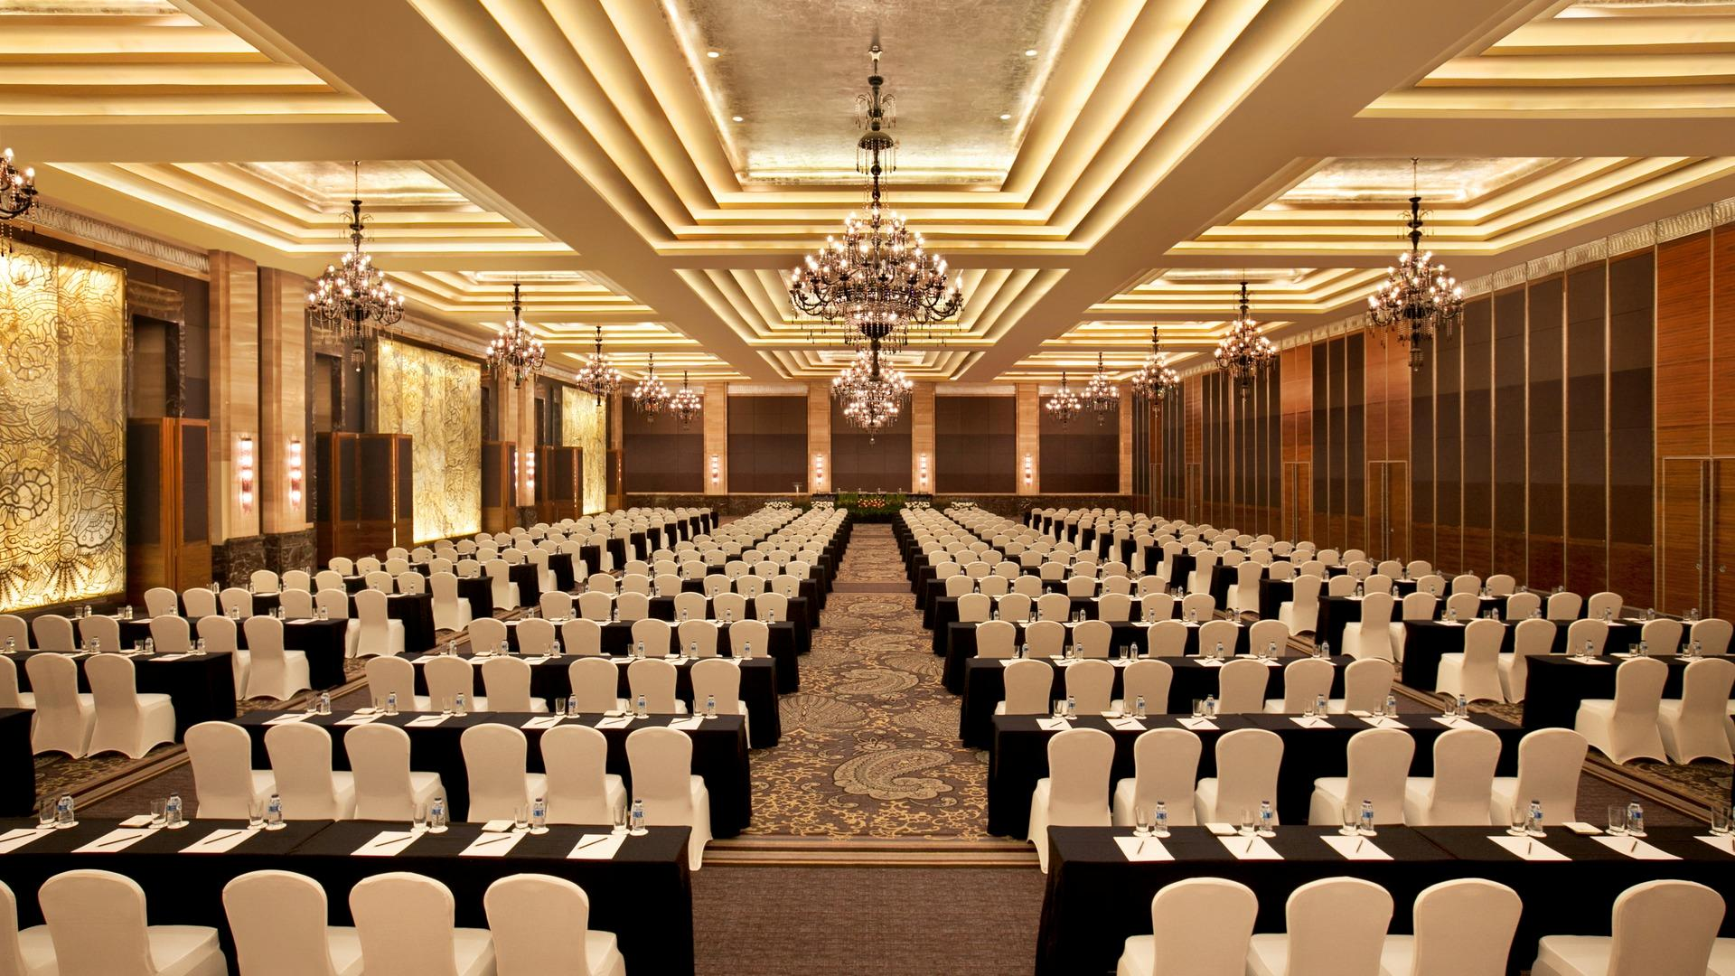
Grand Ballroom

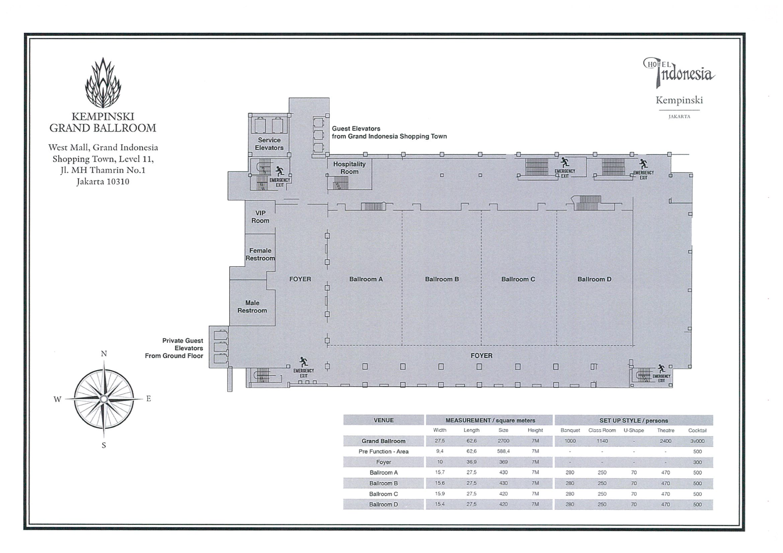
Grand Ballroom Layout
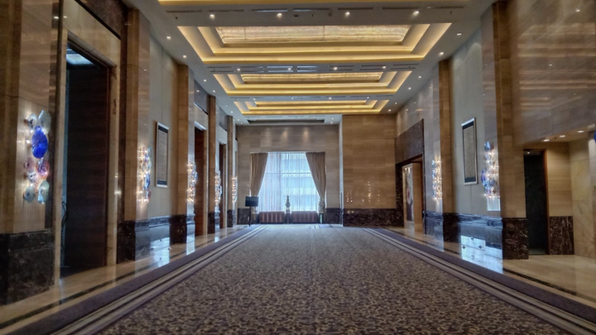
Grand Ballroom Foyer

ACCOMODATION – JAKARTA:
5-Star Hotel ⭐⭐⭐⭐⭐
HOTEL INDONESIA KEMPINSKI JAKARTA
📍Jl. MH Thamrin No.1, RT.1/RW.5, Menteng, Jakarta Pusat, DKI Jakarta 10310
https://maps.app.goo.gl/Bh6Mcoyqh5Qgebky9

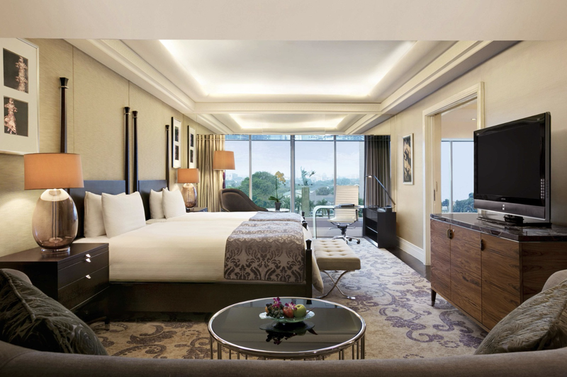
Deluxe Room – Twin Bed (Sharing)

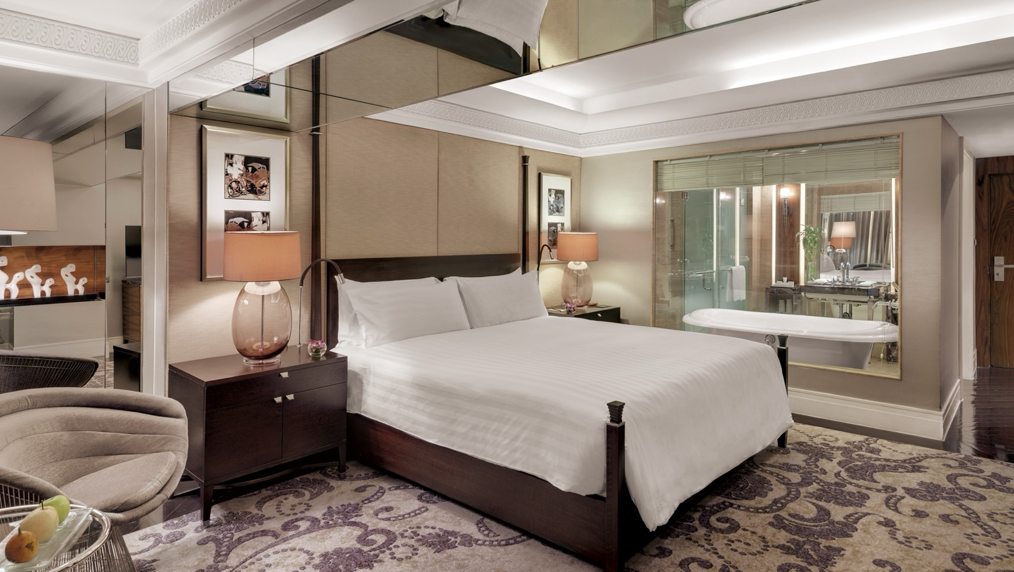
Deluxe Room – Single Bed
4-Star Hotel ⭐⭐⭐⭐
HOTEL GRAND SAHID JAYA
📍Jl. Jendral Sudirman No. 86, Karet Tengsin, Tanah Abang, Jakarta Pusat, DKI Jakarta 10220
https://maps.app.goo.gl/5foLhpHU6C7TZSUQA

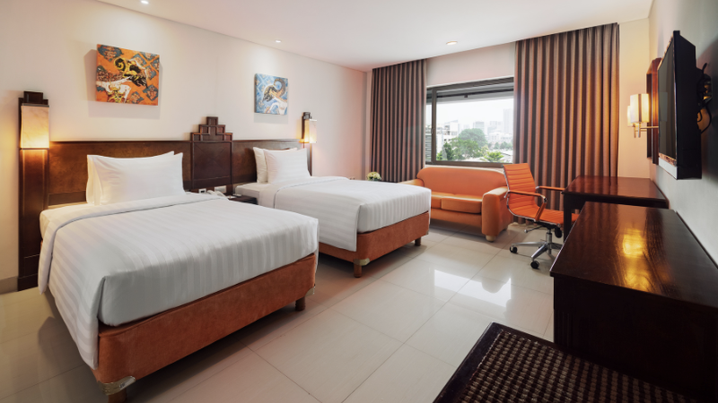
Deluxe Room – Twin Bed (Sharing)

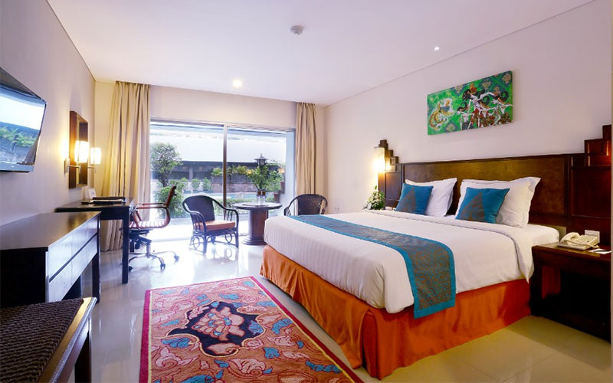
Deluxe Room – King Size (Single)

ACCOMODATION – BANDUNG:
4-Star Hotel ⭐⭐⭐⭐
MERCURE BANDUNG CITY CENTRE
📍Jl. Lengkong Besar No.8, Cikawao, Lengkong, Kota Bandung, Jawa Barat 40261
https://maps.app.goo.gl/Lzwbxe8N8w3mM8rQA

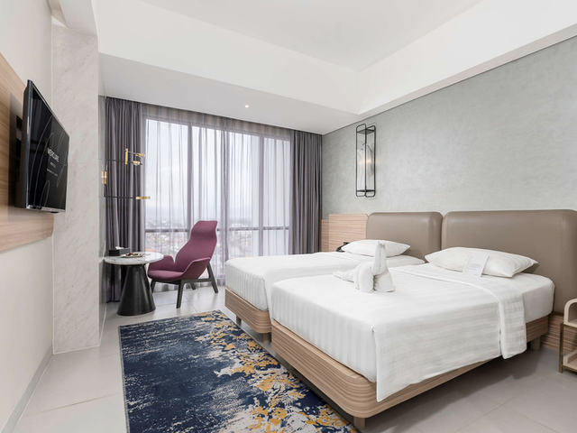
Superior Room – Twin Bed (Sharing)

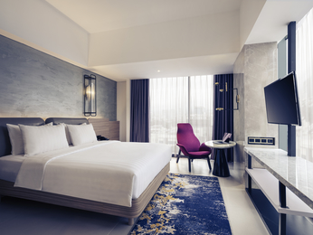
Superior Room – Queen Size (Single)

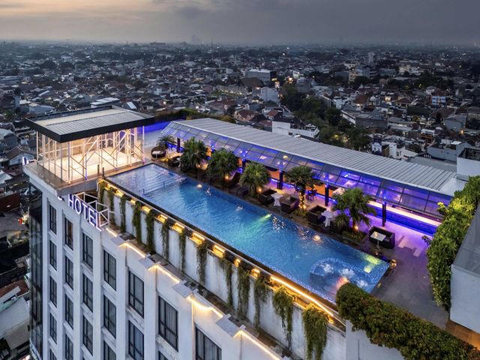
Rooftop Swimming Pool

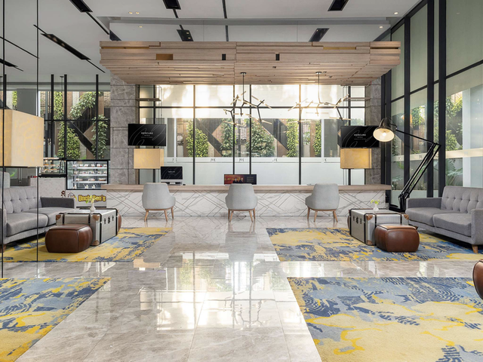
Lobby Hotel

